**DAILY ONLINE ACTIVITIES SUMMARY**

|  |  |  |  |  |  |  |  |
| --- | --- | --- | --- | --- | --- | --- | --- |
| **Date:** | | **27/5/2020** | | | | | |
| **Name of the Faculty** | | **REENA LOBO** | | | | | |
| **No. of Students Allotted for monitoring** | | | | | **19** | | |
| **Progress** | | | | | **GOOD** | | |
| **Whether collected report from all the allotted students** | | | | | **17** | | |
| **Online Test Summary** | | | | | | | |
| **Subject** |  | | | | | | |
| **Semester** |  | | | **Duration** | |  | |
| **No. of students Taken** | | |  | **Passing %** | |  | |
| **Certification Course Summary** | | | | | | | |
| **Course** | | Attended webinar on The Future of Artificial Intelligence Completed Module 3 of Python For Data Science | | | | | |
| **Certificate Provider** | |  | | | **Duration** | | **5days** |
| **Coding Challenges** | | | | | | | |
| **Problem Statement:** | | | | | | | |
| **Status:** | | | | | | | |
| **Uploaded the report in Github** | | | | | **yes** | | |
| **If yes Repository name** | | | | | <https://github.com/reenalobo/ONLINE-ACTIVITY-REPORT/upload/master> | | |
| **Uploaded the report in slack** | | | | | **yes** | | |

Certification Course Details: (Attach the snapshot and briefly write the report for the same)

**Attended webinar on The Future of Artificial Intelligence**

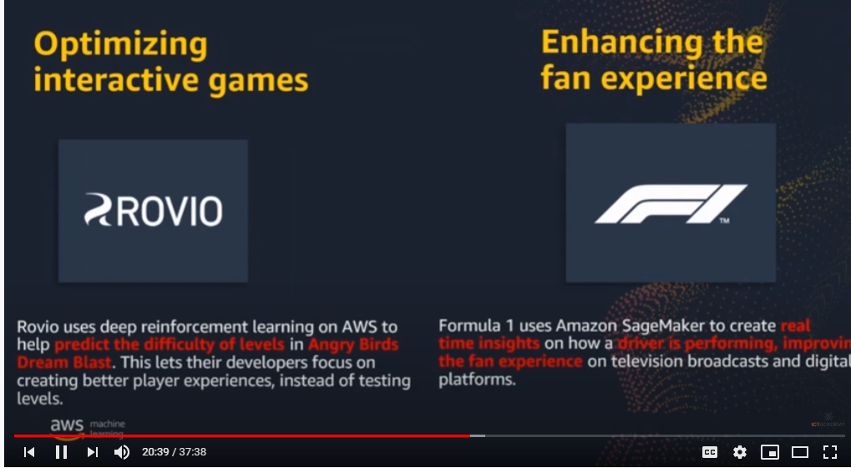

STUDENTS REPORT:

ROHAN MAHAVEER:

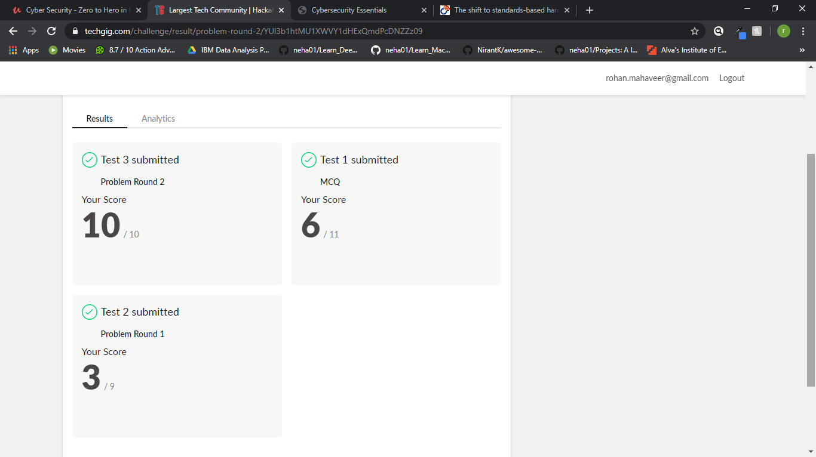

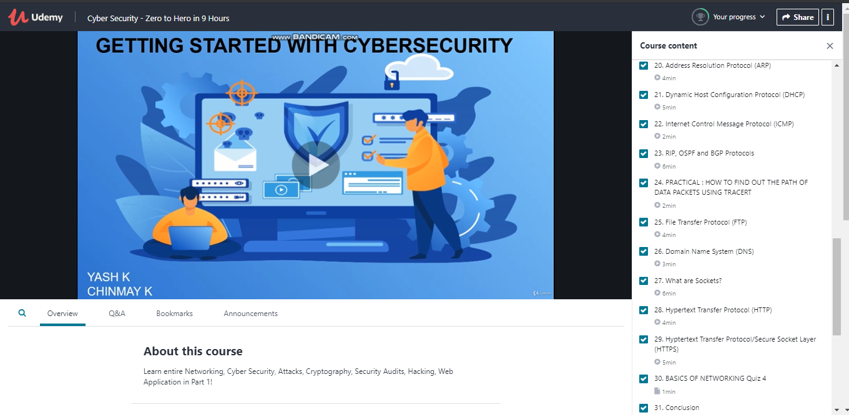

ATISH:

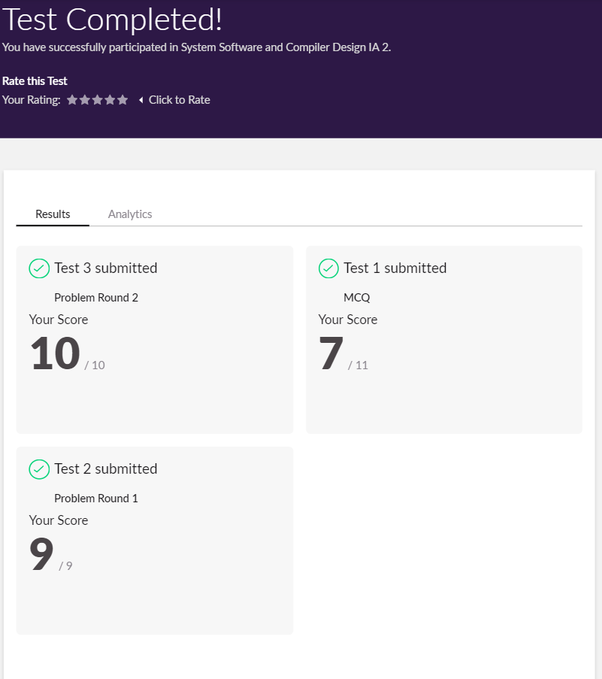

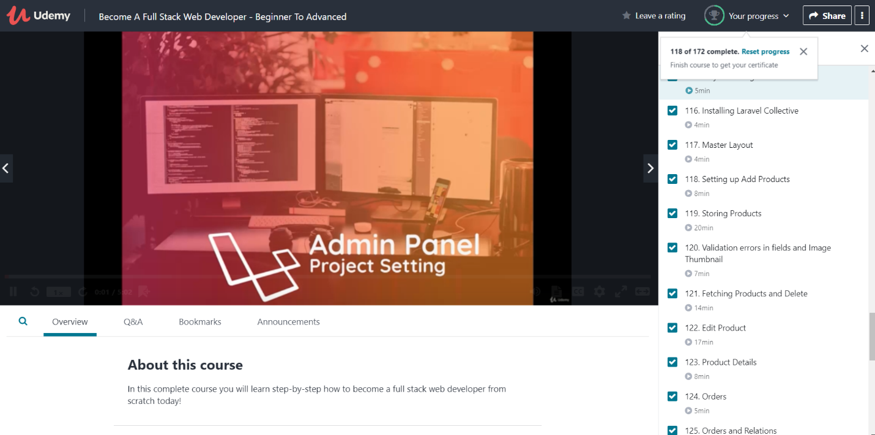

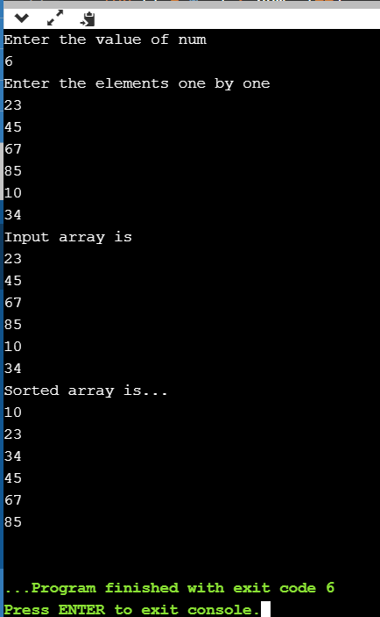

**Shah Dhruvil Amit:**



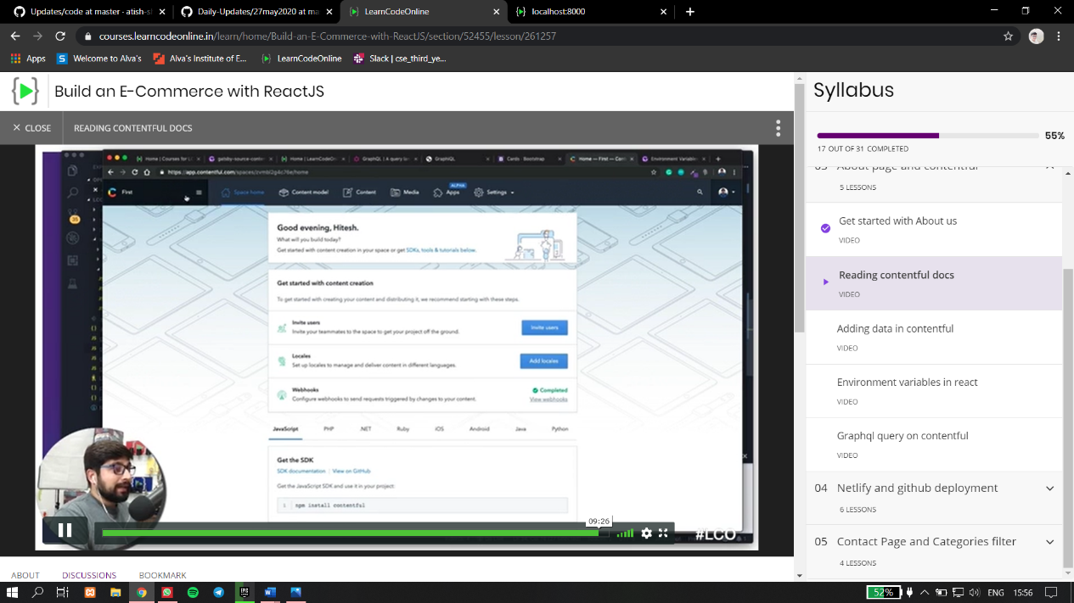



**Raksha S:**

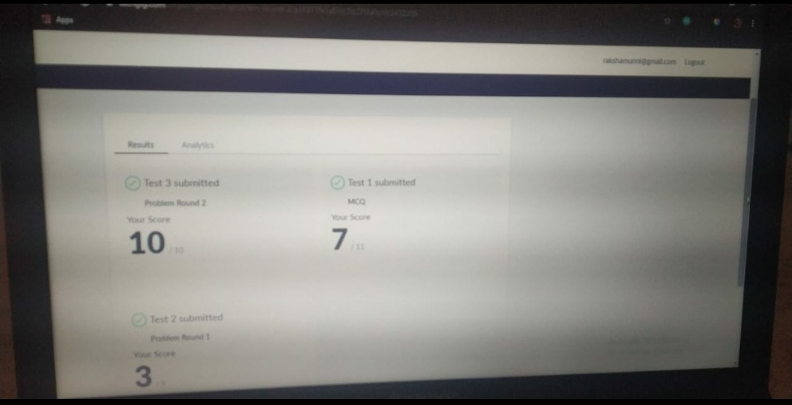

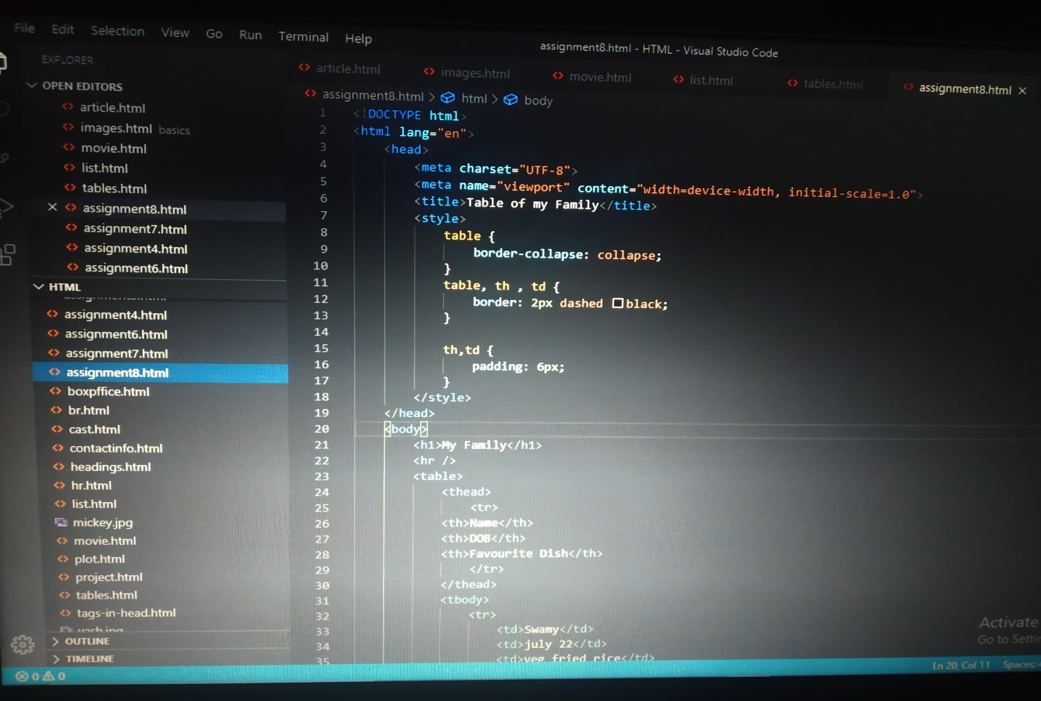

**Preethi:**

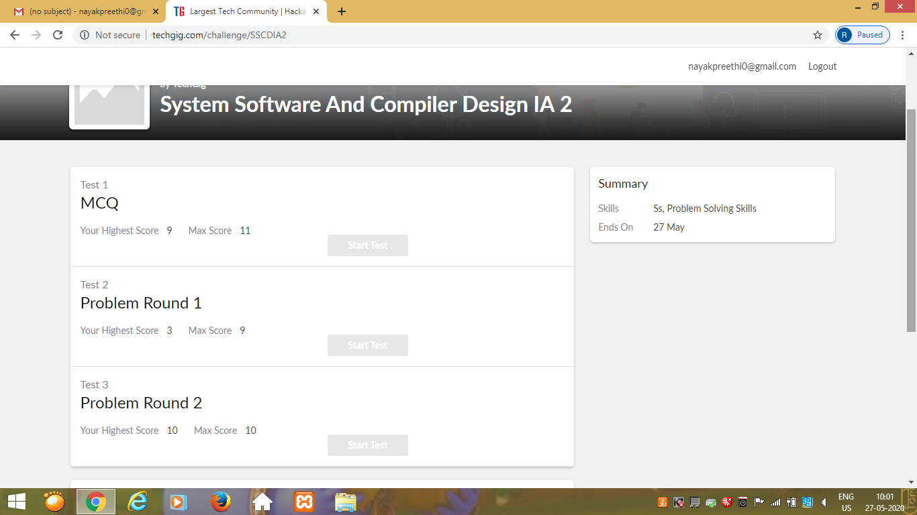

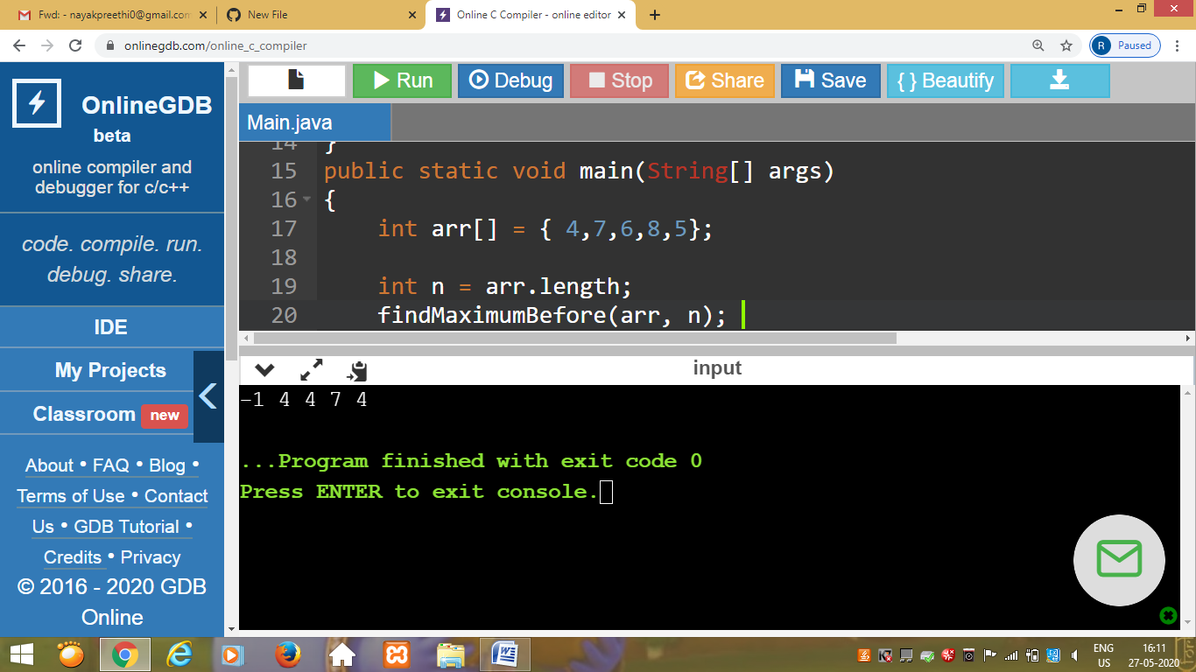

Rani:

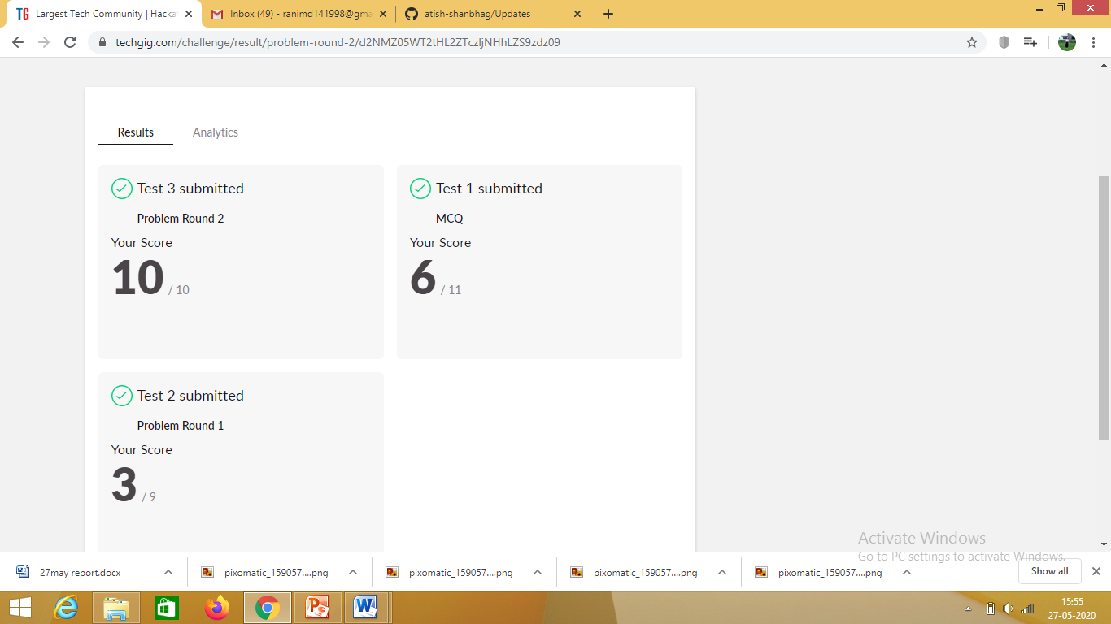

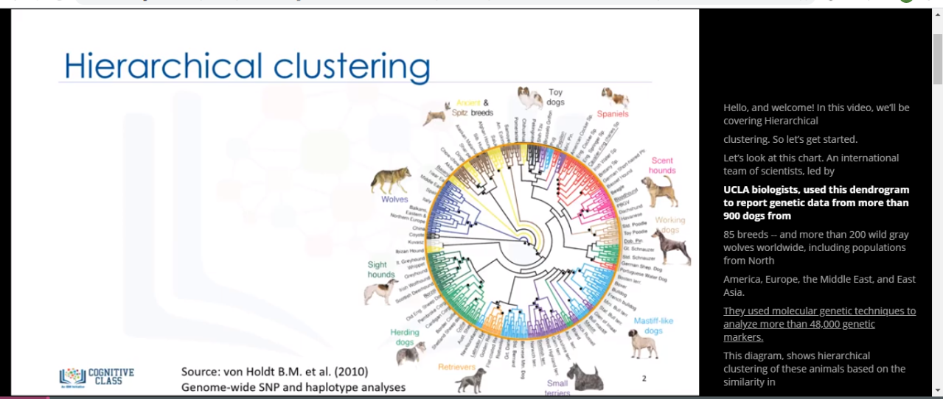

**Pranav L M:**

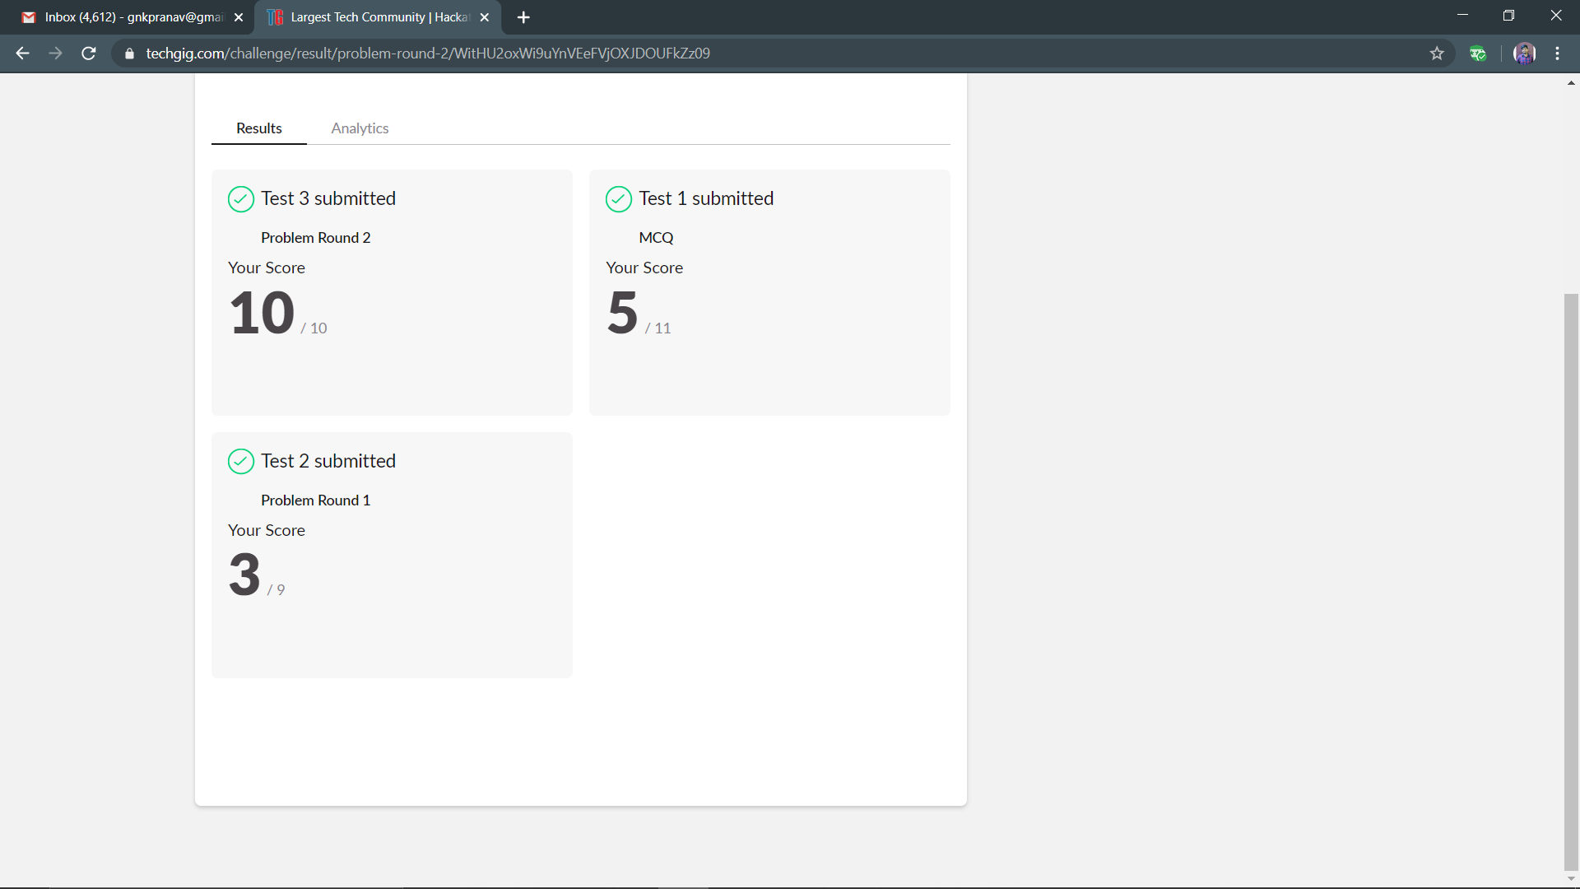

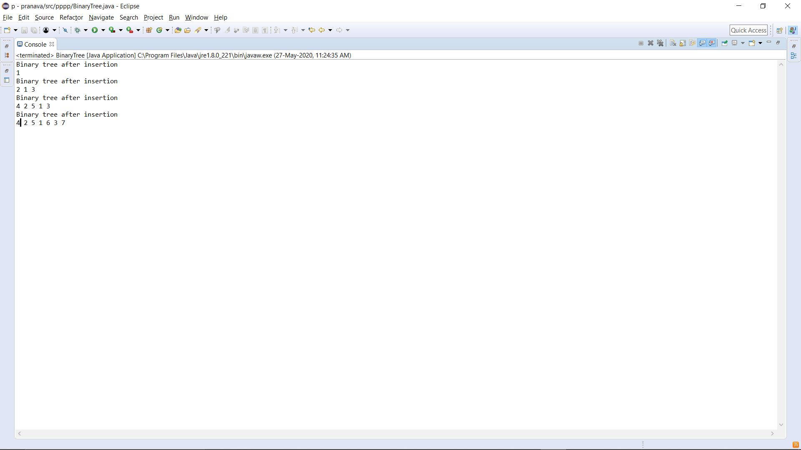

**Priyanka Killedar:**

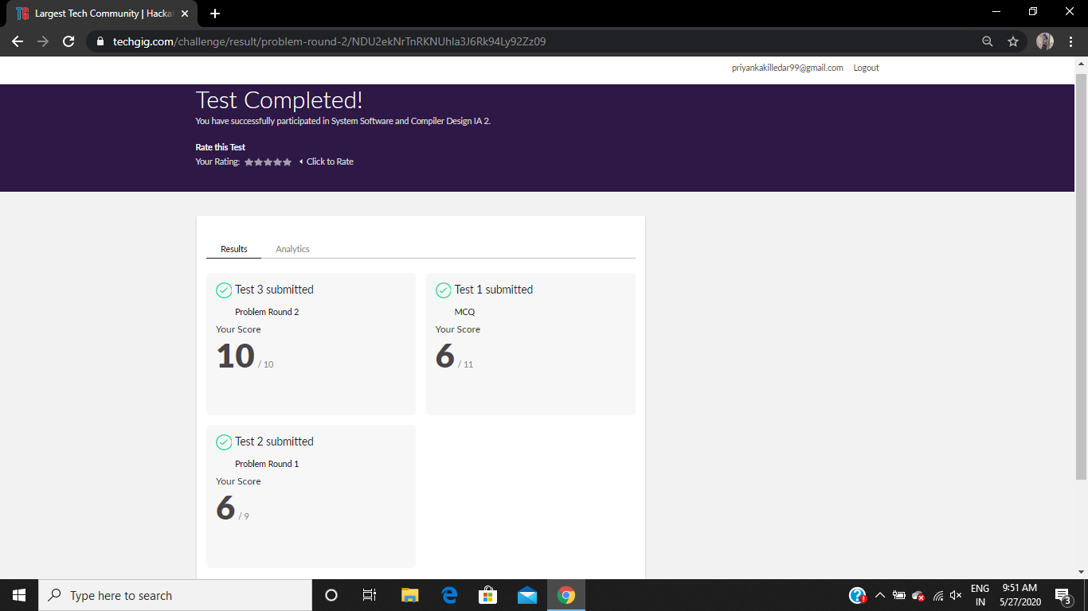

RAVALI:



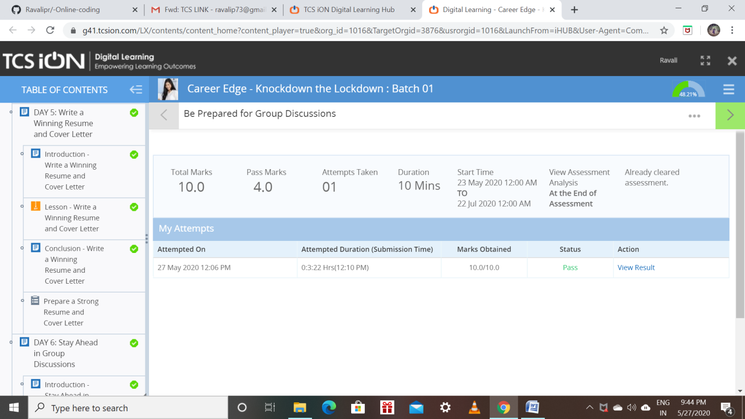

Priyanka:

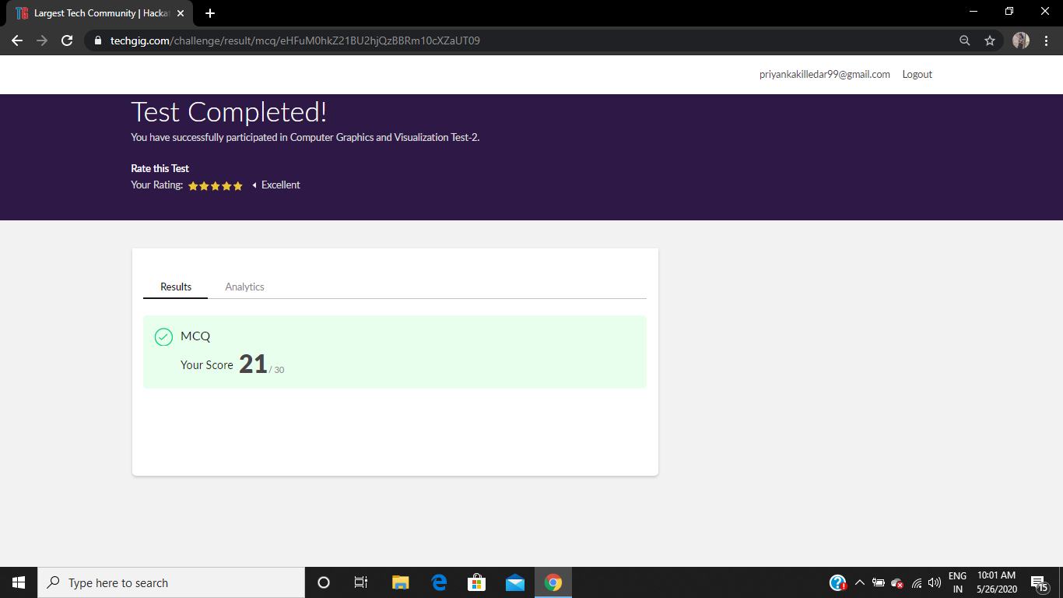

Ravali:

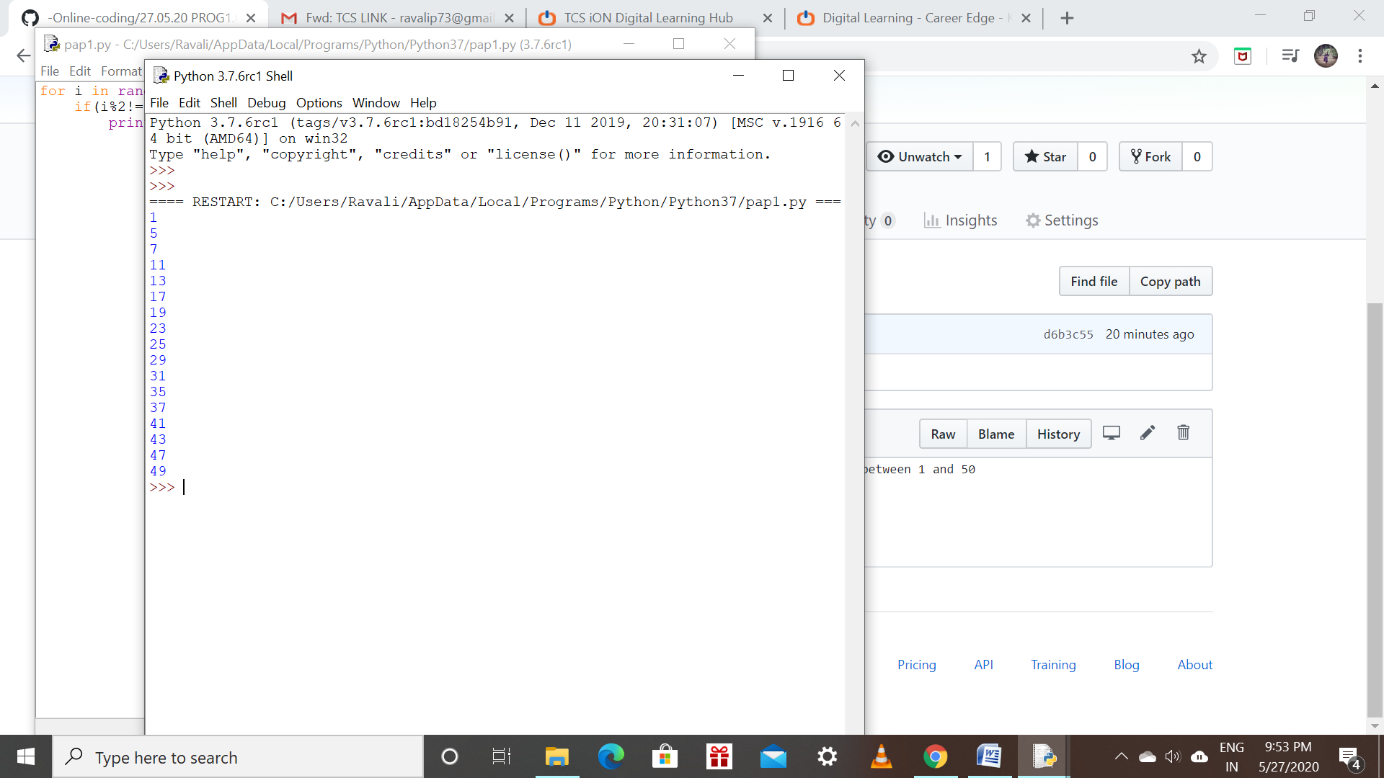

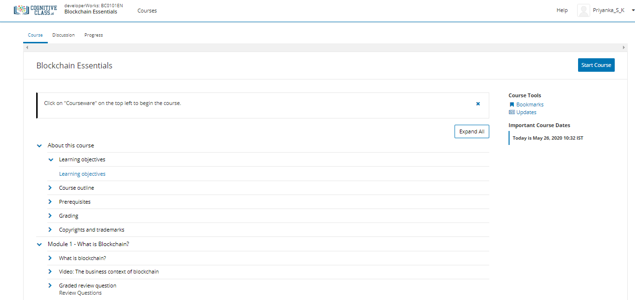

Priya:

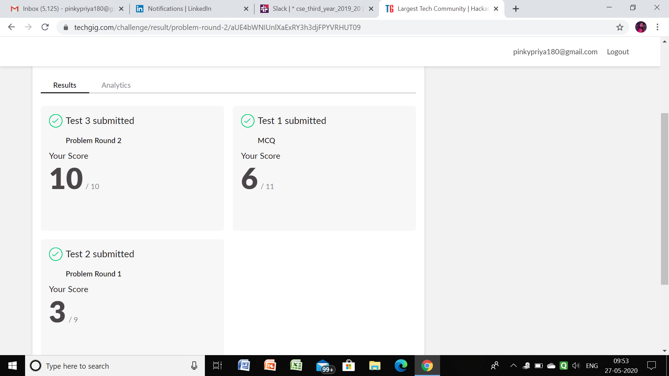

Rousha:

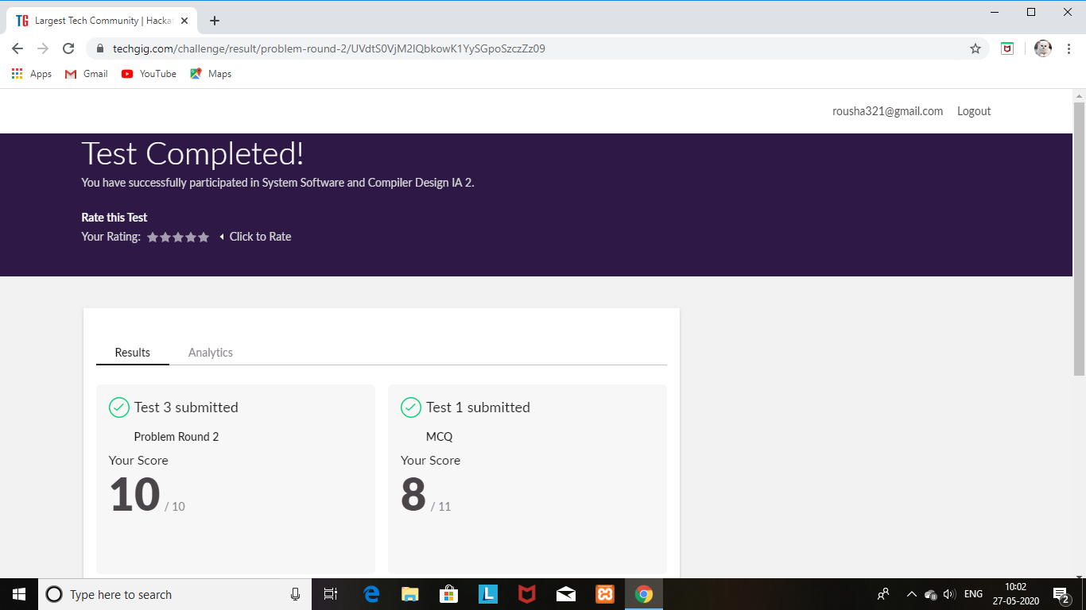

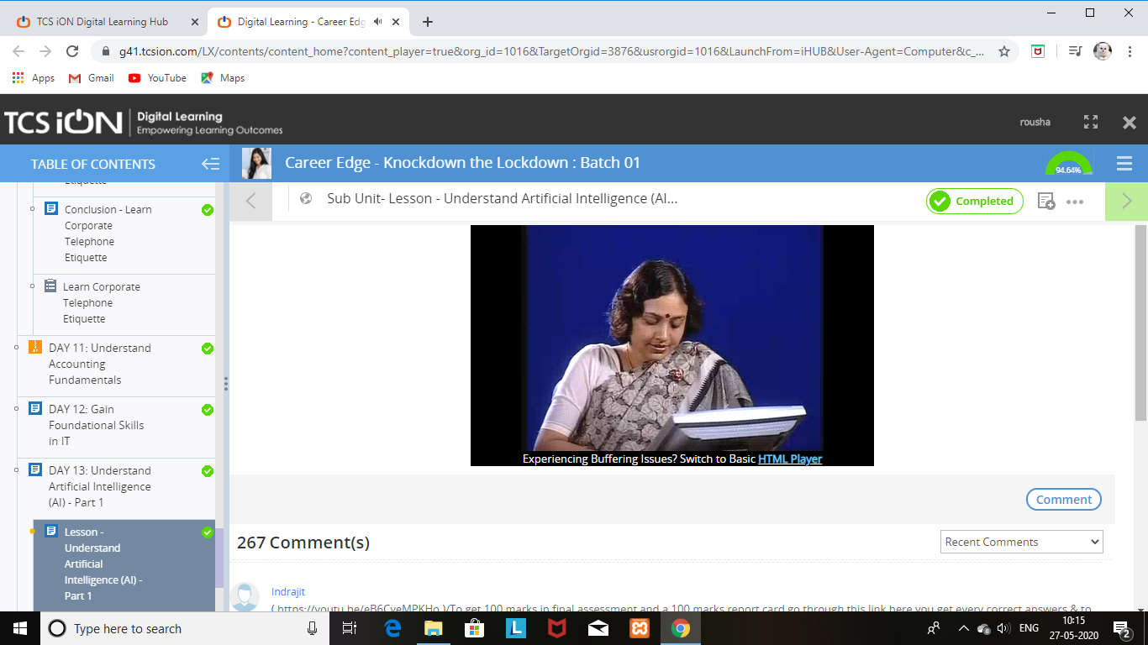

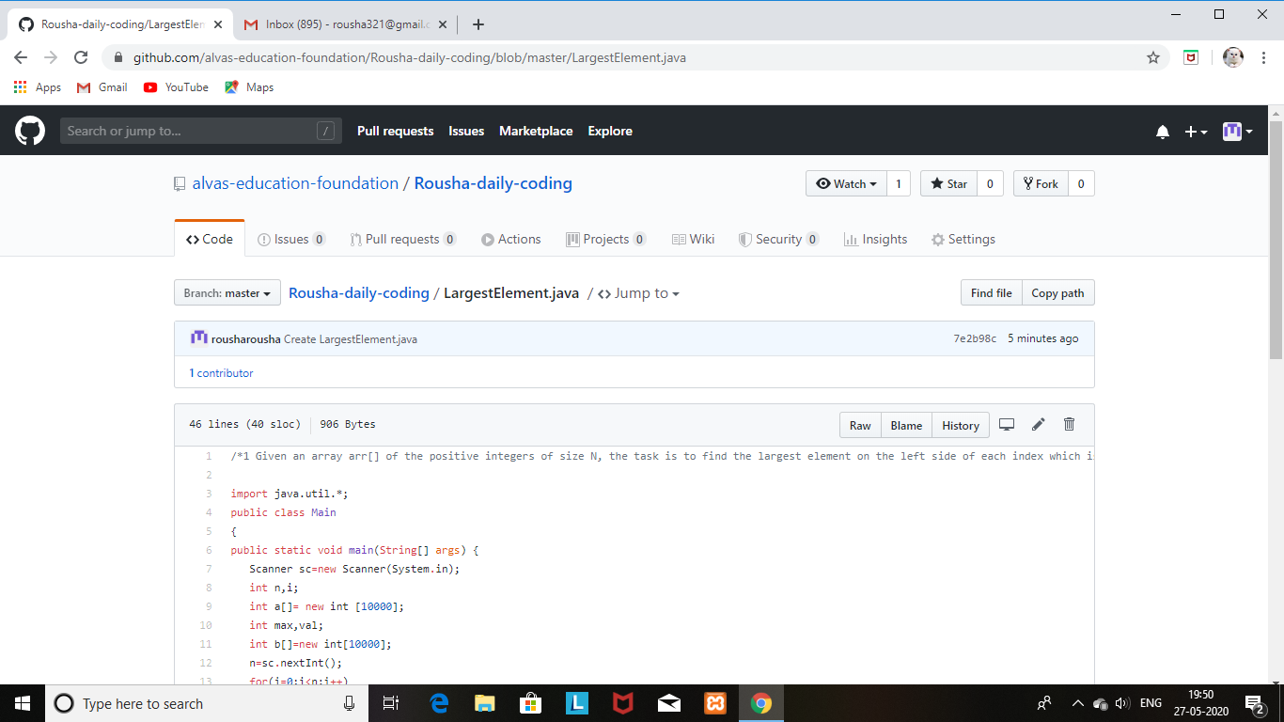

SHAIFA:

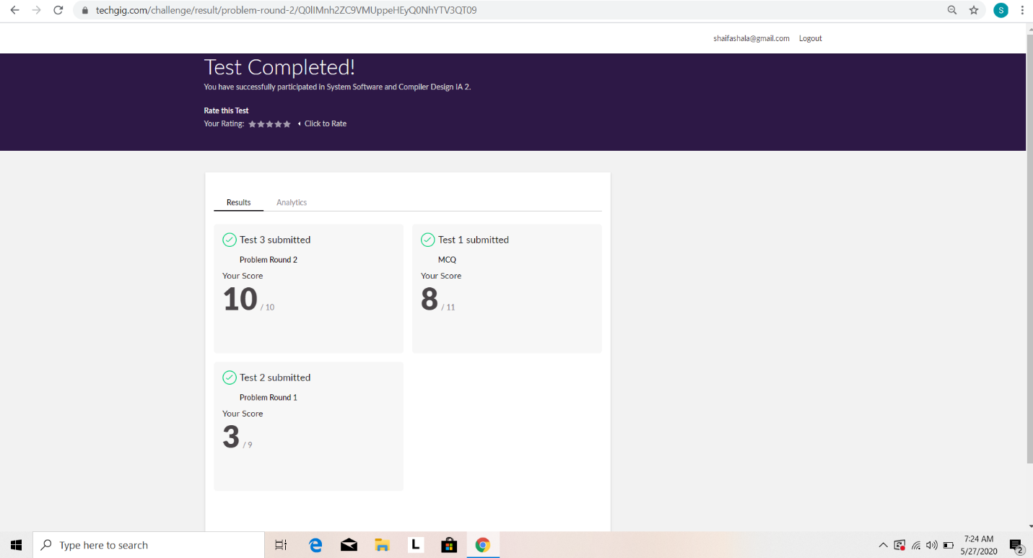

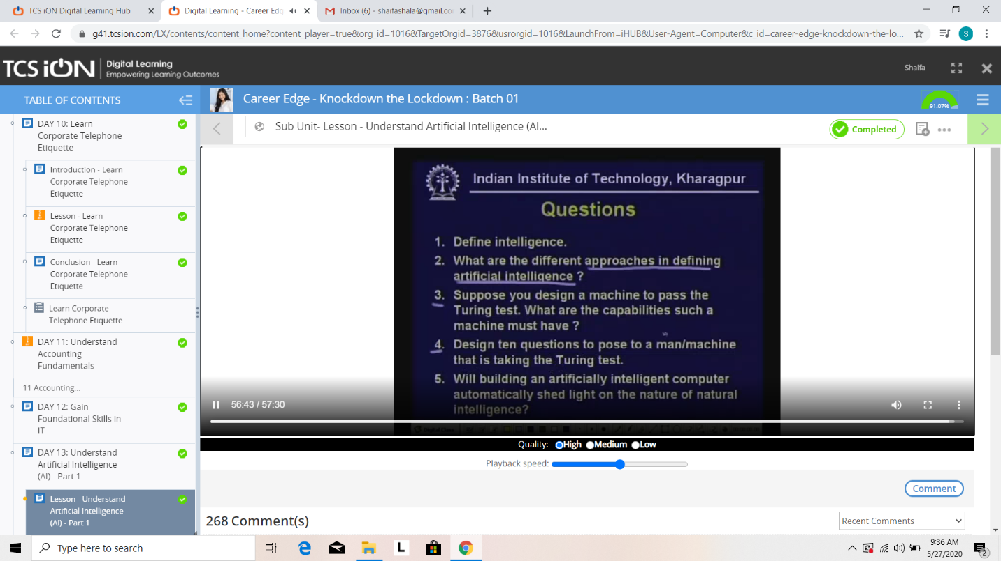

Rani:



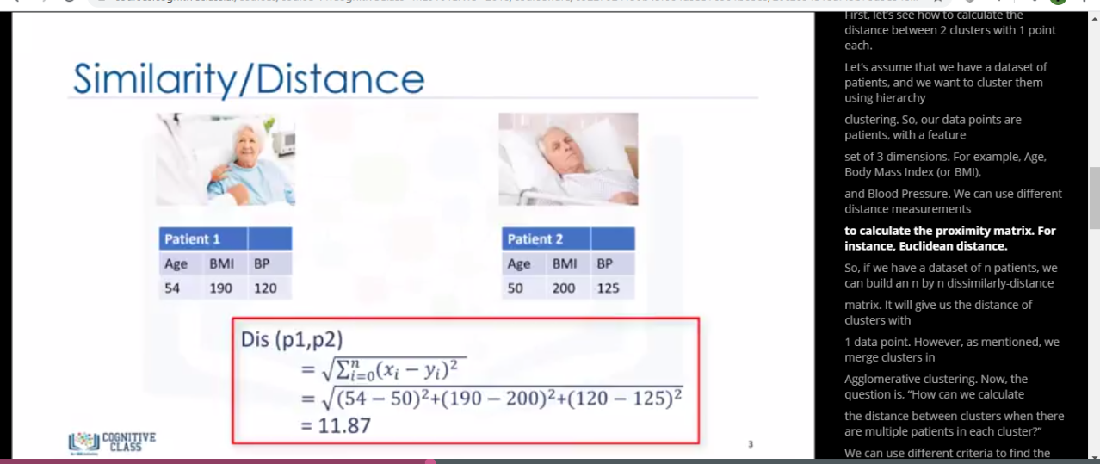



Praveen kumar:

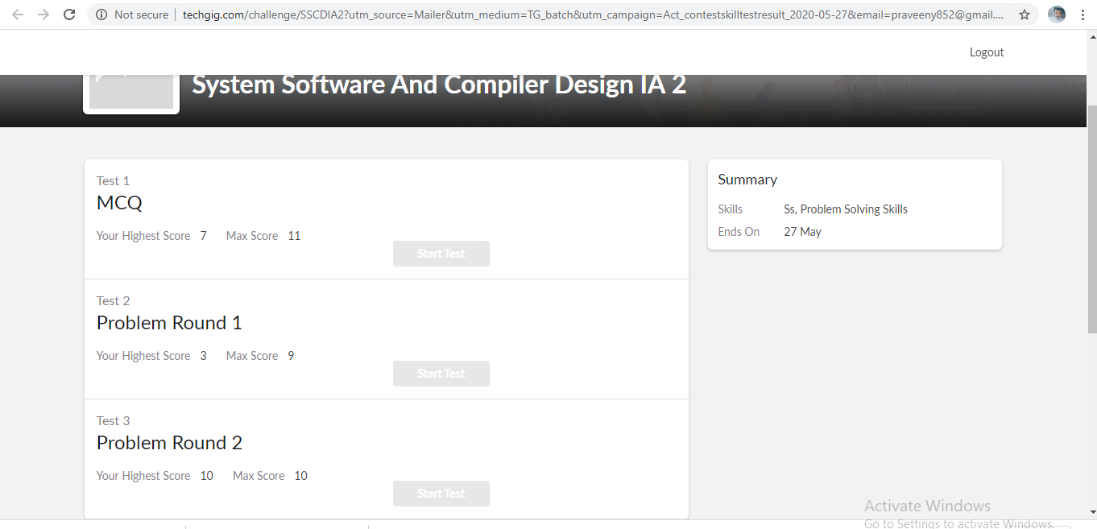

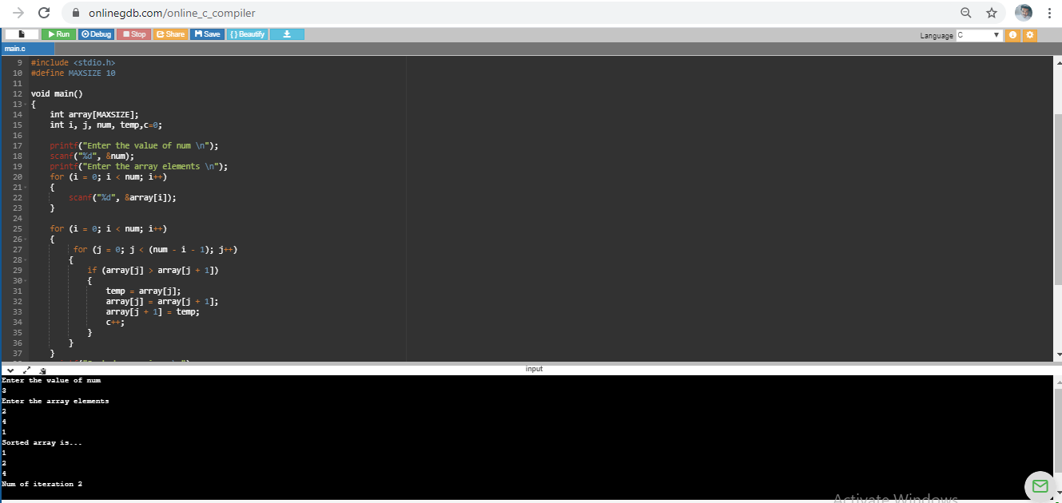

Rohan vasista:

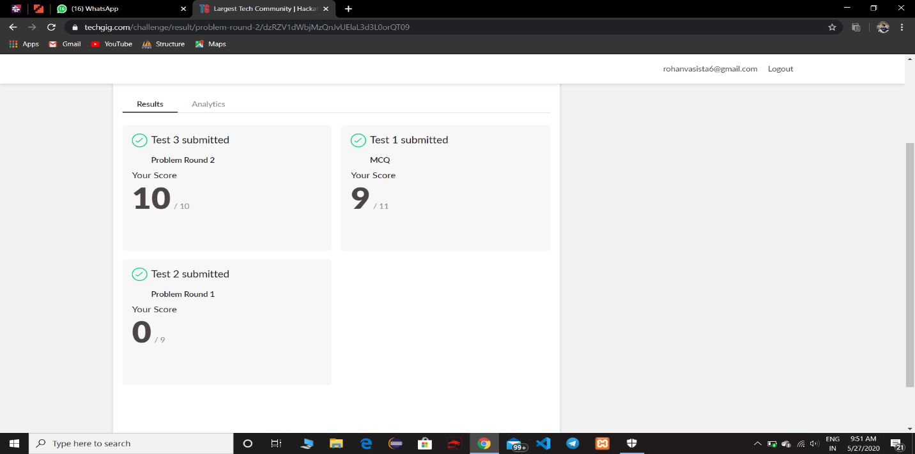

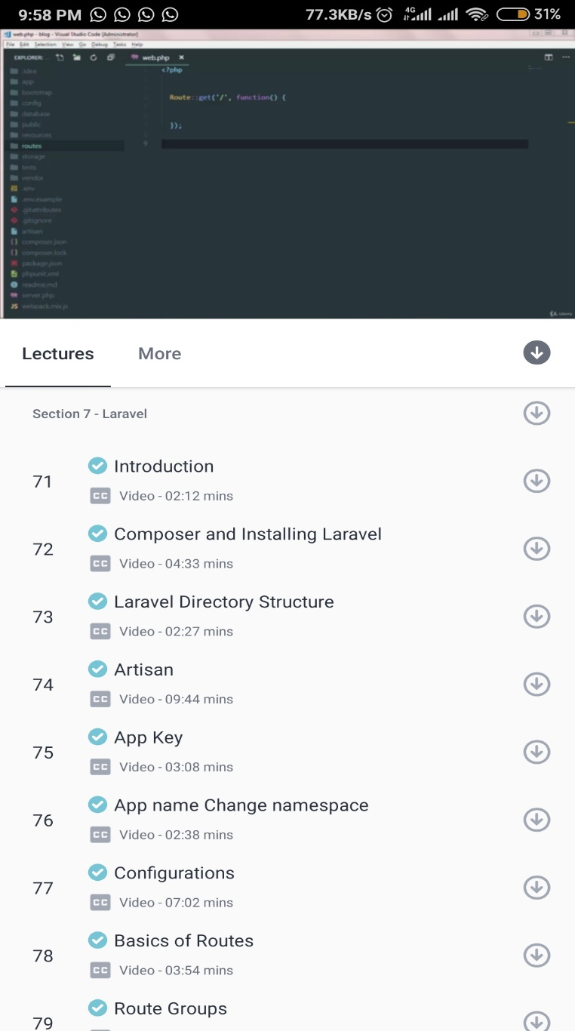

Sana:

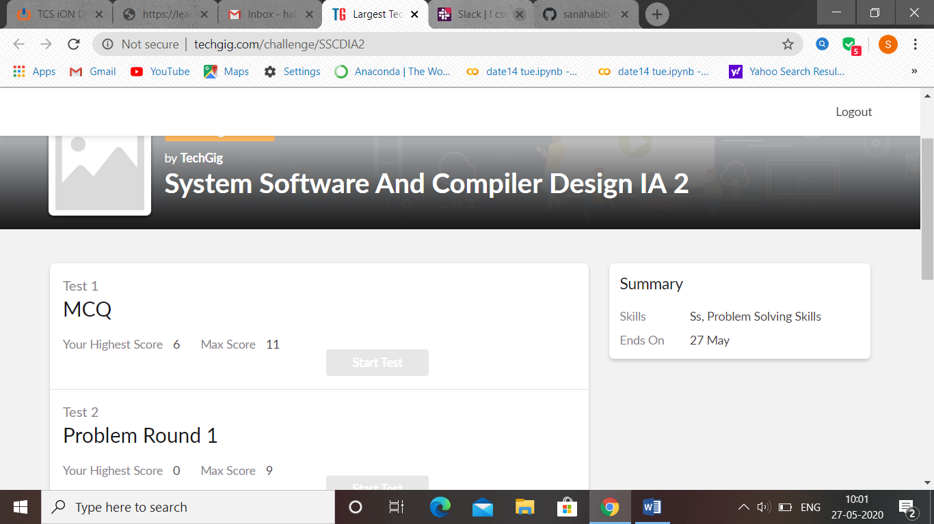

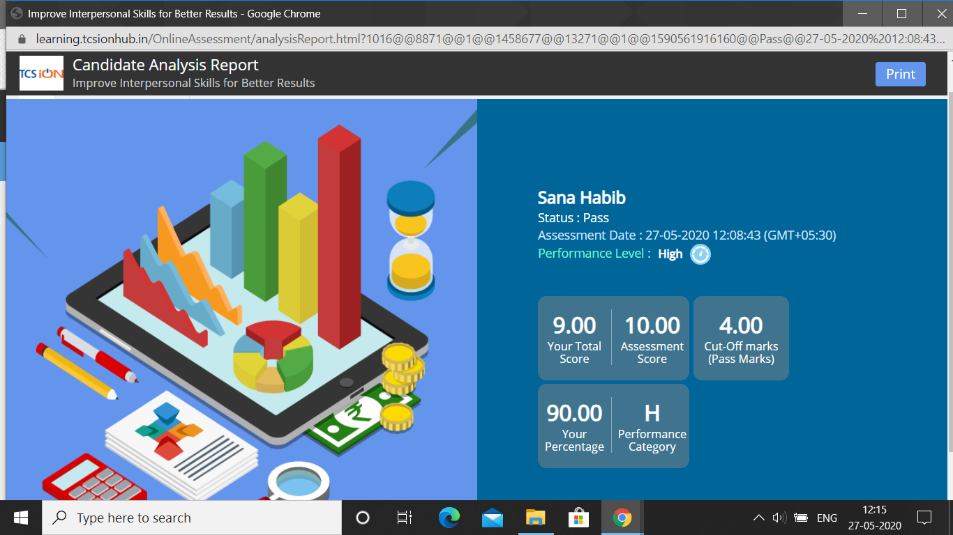

Rachana:

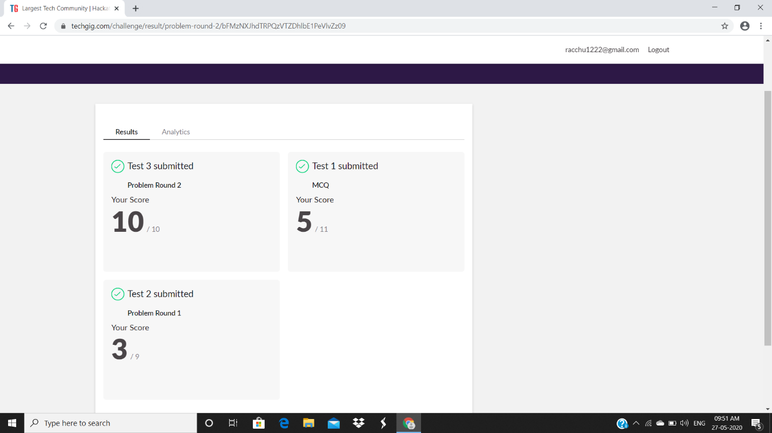

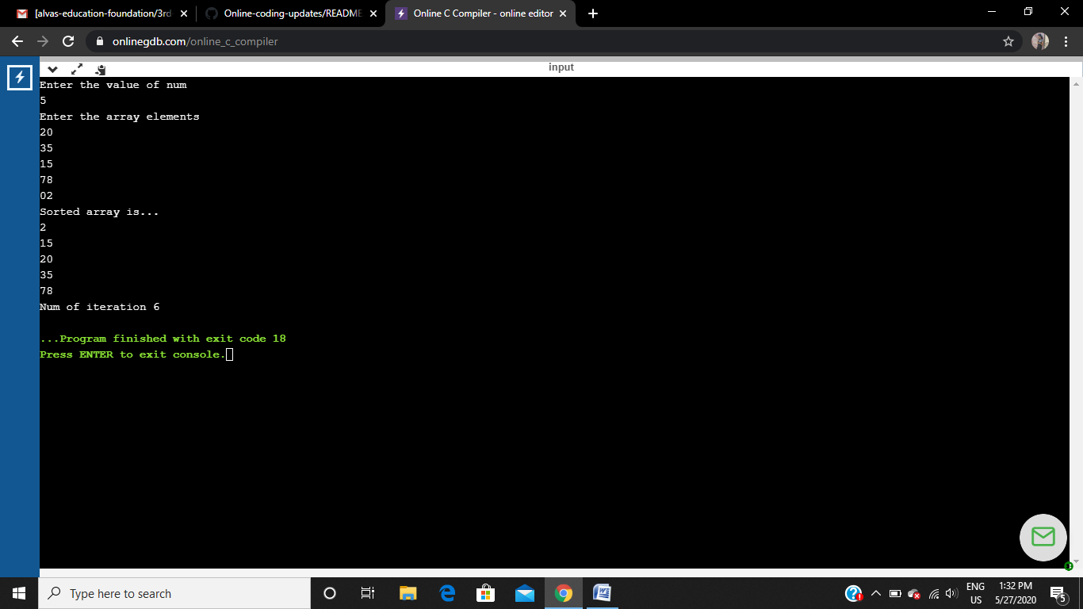

Raghavi:

